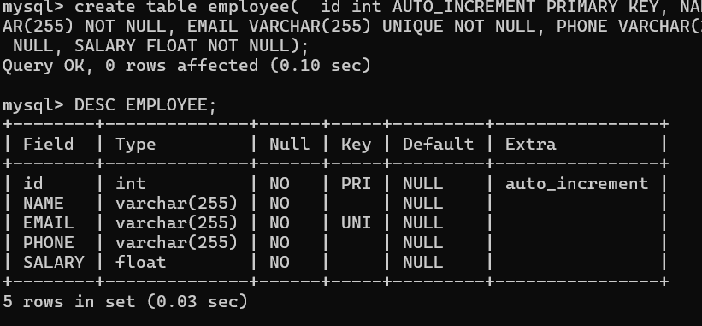

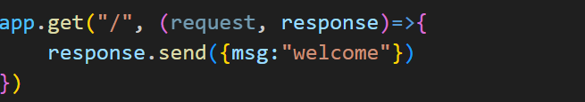

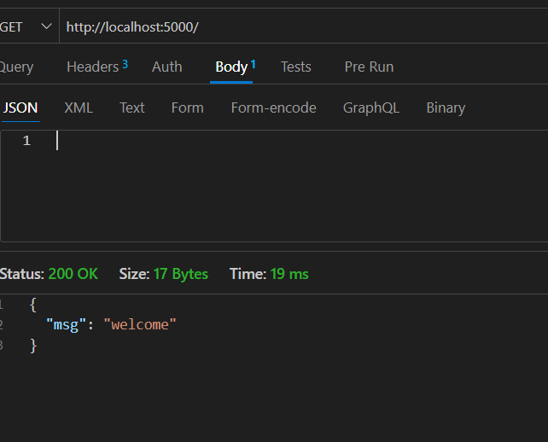

app.post('/api/employees', (request, response)=>{

    try {

        const data = request.body

        const qry= ` insert into employee values(${data.id}, '${data.name}', '${data.email}','${data.phone}',${data.salary})`

        conn.query(qry,(error,result)=>{

            if (error) {

                response.send({msg:" inserting error"})

            } else {

                response.send({msg:" inserted successful"})

            }

        })

    } catch (error) {

        console.log(error)

        res.send({msg:"somthing wrong"})

    }

})

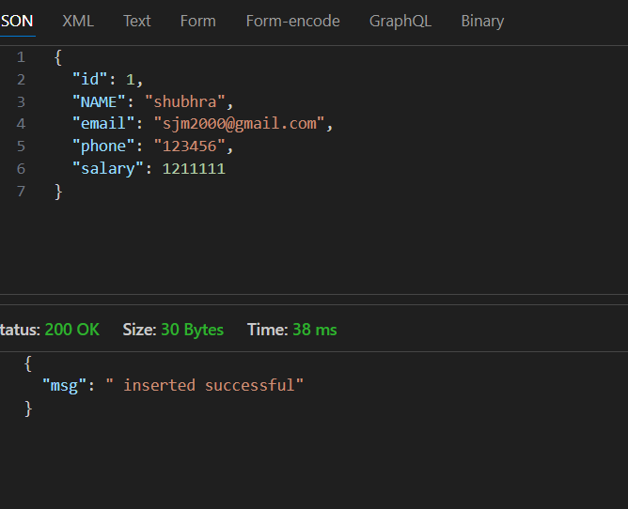

app.post('/api/employees', (request, response)=>{

    try {

        const data = request.body

        if(!data.id||!data.name||!data.email||!data.phone||!data.salary){

            response.send({msg:"all field required"})

        }

        const qry= ` insert into employee values(${data.id}, '${data.name}', '${data.email}','${data.phone}',${data.salary})`

        conn.query(qry,(error,result)=>{

            if (error) {

                    response.send({msg:" inserting error"})

            } else {

                response.send({msg:" inserted successful"})

            }

        })

    } catch (error) {

        console.log(error)

        res.send({msg:"somthing wrong"})

    }

})

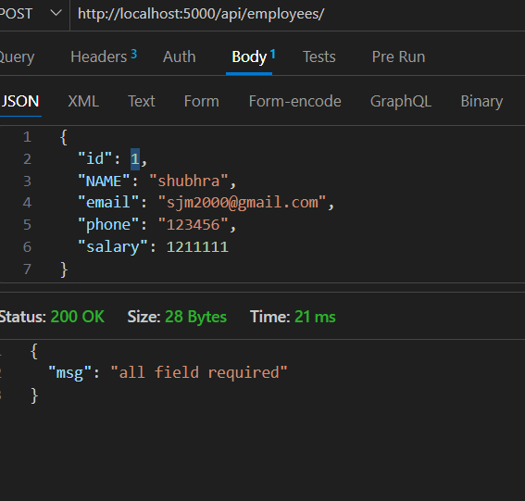

app.get("/api/employees",(request, response)=>{

    try {

        const qry= `select \* from employee`

    conn.query(qry,(error,result)=>{

        if (error) {

            response.send({msg:" fetching error"})

        } else {

            response.send(result)

        }

    })

    } catch (error) {

        console.log(error)

        response.send({msg:"somthing wrong"})

    }

})

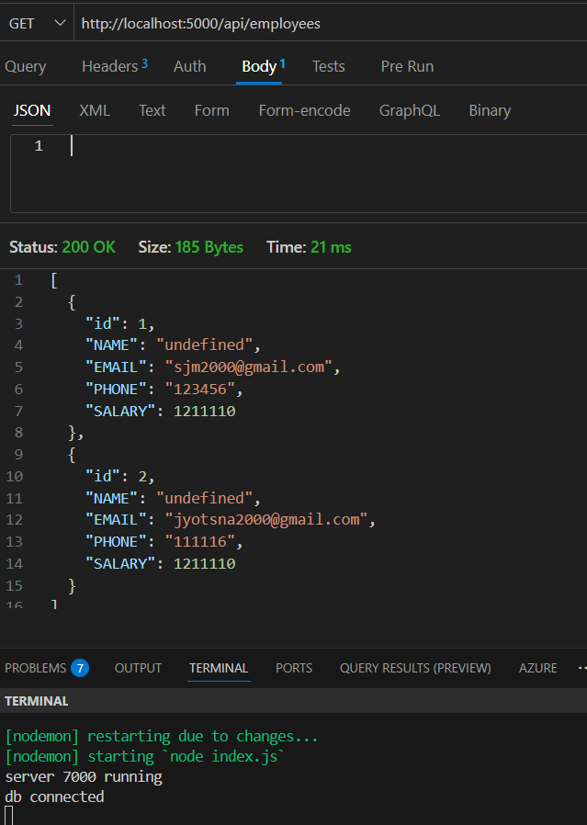

app.put('/api/employees/:id', (request, response)=>{

    try {

        const id = parseInt(request.params.id)

        const data = request.body

        const qry= ` update employee set name='${data.name}', email= '${data.email}', phone= '${data.phone}', salary=${data.salary} where id = ${id}`

        conn.query(qry,(error,result)=>{

            if (error) {

                response.send({msg:" update error"})

            } else {

                response.send({msg:" updated successful"})

            }

        })

    } catch (error) {

        console.log(error)

        res.send({msg:"somthing wrong"})

    }

})

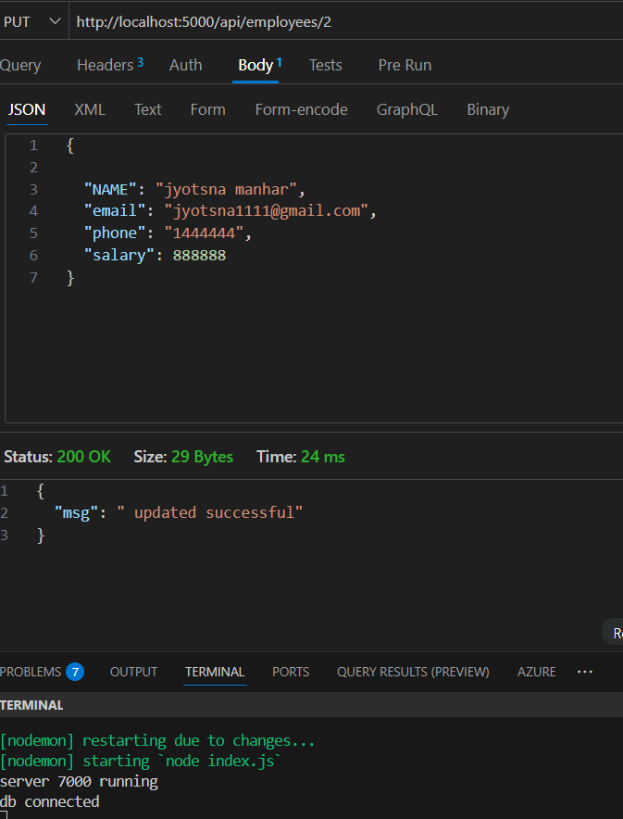

app.delete("/api/employees/:id",(request, response)=>{

    try {

        const id = parseInt(request.params.id)

        const qry= `delete from employee where id=${id}`

    conn.query(qry,(error,result)=>{

        if (error) {

            console.log(error)

            response.send({msg:" delete error"})

        } else {

            response.send({msg:"deleted"})

        }

    })

    } catch (error) {

        console.log(error)

        response.send({msg:"somthing wrong"})

    }

})

